Personal Information: Please read and complete both sides
Name
Address

Phone: Residence ( ) Business ( )
Cellular ( ) Email:__________________________________
Date of Birth: (dd/mm/yy) Age: Gender: __________ Pronoun __________
Name of Parent/Guardian if patient is under 16:
Family Physician: Phone: ( )
Address:

Have you had x-rays taken for this complaint? ___Y ___N

Is this a work-related injury? ___Y ___N If yes, date of accident:

Is this a motor vehicle accident? ___Y ___N If yes, date of accident:

Have you ever seen another chiropractor? ___Y ___N

Did your medical doctor recommend that you seek chiropractic care? ___Y ___N

If necessary, may we contact your medical doctor? ___Y ___N

For privacy purposes, may we leave a message at home? ___Y ___N At work? ___Y ___N

May we email you with appointment times and special events in the office? ___Y ___N

Current Occupation:
Please indicate how you wish to be addressed: __Mr __Mrs __Ms __Miss __ First Name __other ________

How did you hear about our office?

Fees:
Chiropractic care is considered “fee-for-service”. All fees are due on the day of service.

Many extended health plans cover chiropractic. When possible, we will direct bill your health plan. Should the claim be denied, it will be your responsibility to review your policy and to submit the claim to be reimbursed by your health carrier. We will be happy to print a receipt to help with your claim.
Current Fees | Initial  Consultation | Subsequent  Visit
Adult | $ 100.00 | $ 55.00
Child/Student | $ 80.00 | $ 45.00

I have read the above information and understand:

- I am responsible for all fees. Some extended health plans and Motor Vehicle Accident claims will be billed on my behalf, however if my claim is denied I am responsible for the bill.
- All clinical records and materials pertaining to my care are the property of this clinic.
- I am considered discharged on my own accord if multiple appointments are missed without notice.
- I am to speak to the Doctor if I have questions or concerns or any unusual symptoms.
- I will call the office to cancel/re-book my appointment should I find I have a conflict.

Signature Date

Confidential Health Information: Patient Name:
Date:

Have you ever been diagnosed with: Please indicate on the figure below, the area of your complaint and describe the discomfort using the symbols given. Please include all affected areas:

High Blood Pressure (Hypertension) Y N
Hardening of the arteries Y N

Diabetes Y N x x x = Burning  = Aching
Heart Disease Y N / / / / = Stabbing o o o = Numbness
Bone spurs on the neck Y N    = Pins and Needles
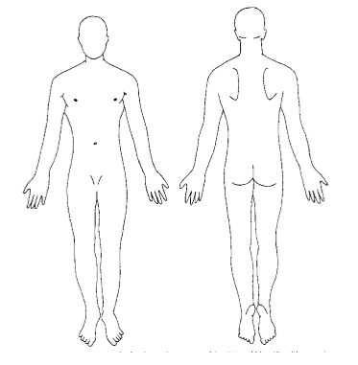
Whiplash Y N
Double vision or Partial loss of vision Y N
Slurred speech or difficulty swallowing Y N
Dizziness Y N
Loss of Consciousness Y N
Numbness or Weakness in any part Y N

Do you suffer from migraines? Y N
Do you smoke? Y N
Do you take oral contraceptives? Y N
Do you take medication regularly? Y N
If so, please list:

(Office-Use Only) Initial Patient History

Complaint:
Onset Acute / Chronic Recurrent / Sudden / Insidious / Traumatic
and Location

Prior occurrence

Prior treatment
X-rays y / n

Character Sharp / Dull / Stabbing / Burning / Aching / Constant

Intensity Current Meds:

Progression
over Day
Sleep:
Radiation Exercise:
Diet: Smoker?
Aggravating
Occupation:

Relieving Stress - Ability to Cope:
Associated Sx: bladder/bowel?

Secondary complaints:
Health Hx: Diabetes / Cancer / Heart Disease / Stroke

Family Hx: Diabetes / Cancer / Heart Disease / Stroke

